Benha university

Faculty of engineering at shoubra

Preparatory year

Name : Mostafa Samy Mohamed Abd El_salam

E_mail : mustafa20900@feng.bu.edu.eg

Code : 2166120200100900

Group : 7

Sec : 41

B.N : 19

Topic : Programming Languages

Github link : [mostafasamy100/html-project-repository (github.com)](https://github.com/mostafasamy100/html-project-repository)

Screenshots : main page

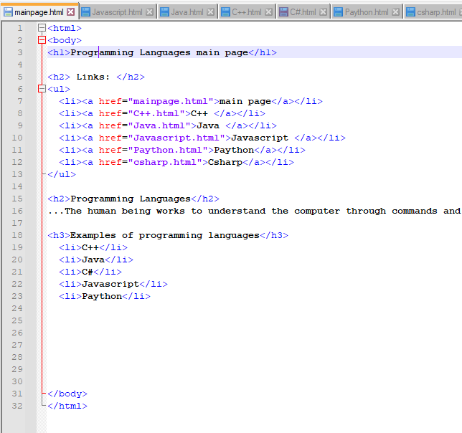

Screenshots : C++

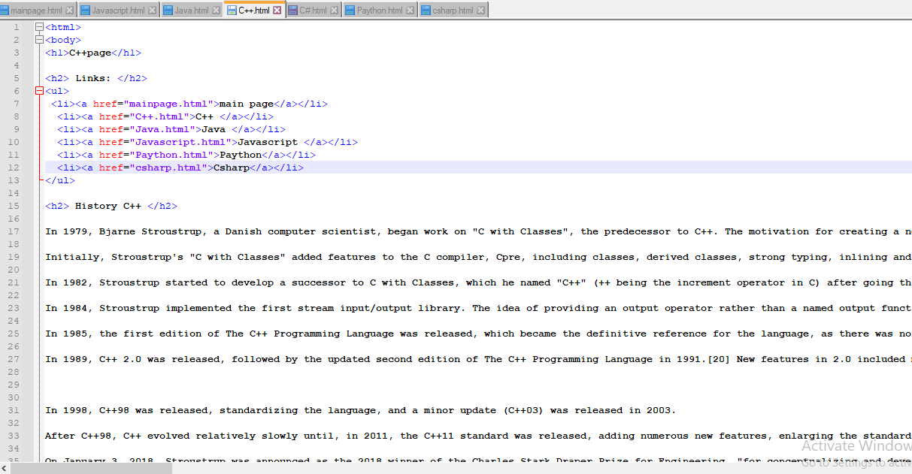

­­­­­­

Screenshots : Java

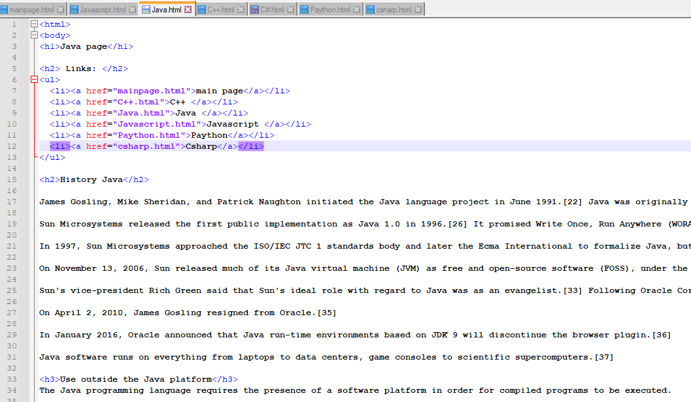

Screenshots : javascript

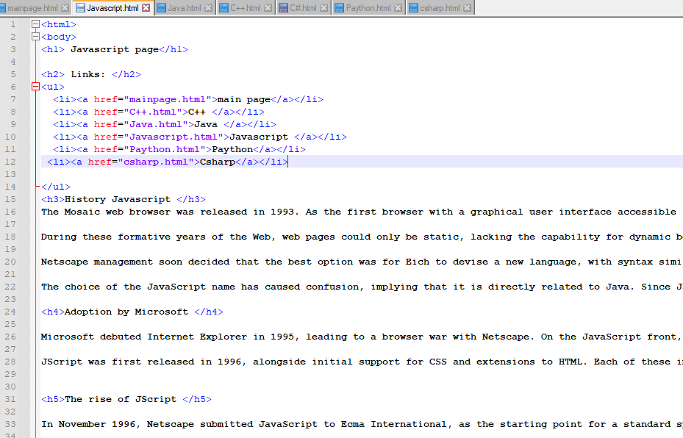

Screenshots : paython

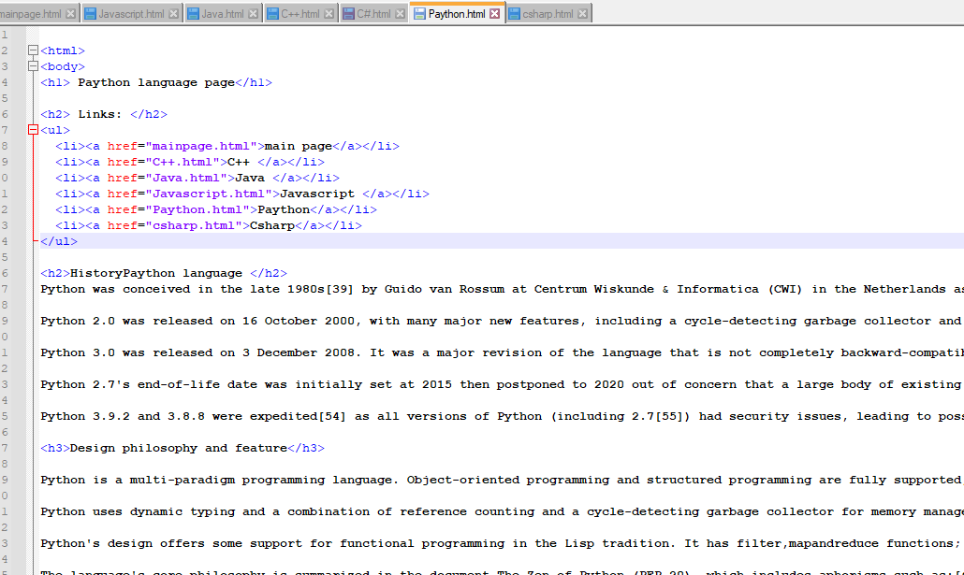

Screenshots : C#

